**NutriApp**



University of Missouri-Kansas City

**Spring 2020**

**Date:** Apr 1 - 2020

**Course:** COMP-SCI 5551

**Class:** Advanced Software Engineering

**Team Members (Group 3):**

1. Abbas Alshaikh
2. Claude Aloumon
3. Jonathan Wolfe
4. Bill Yerkes

**CS5551 Project Increment 1**

**Proposal & Plan Report** <https://github.com/JAWolfe04/CS5551-Group-Project/blob/master/Documentation/ASE%20-%20Project%20Proposal.docx>

**Detail Design of Features**

**Wireframe**

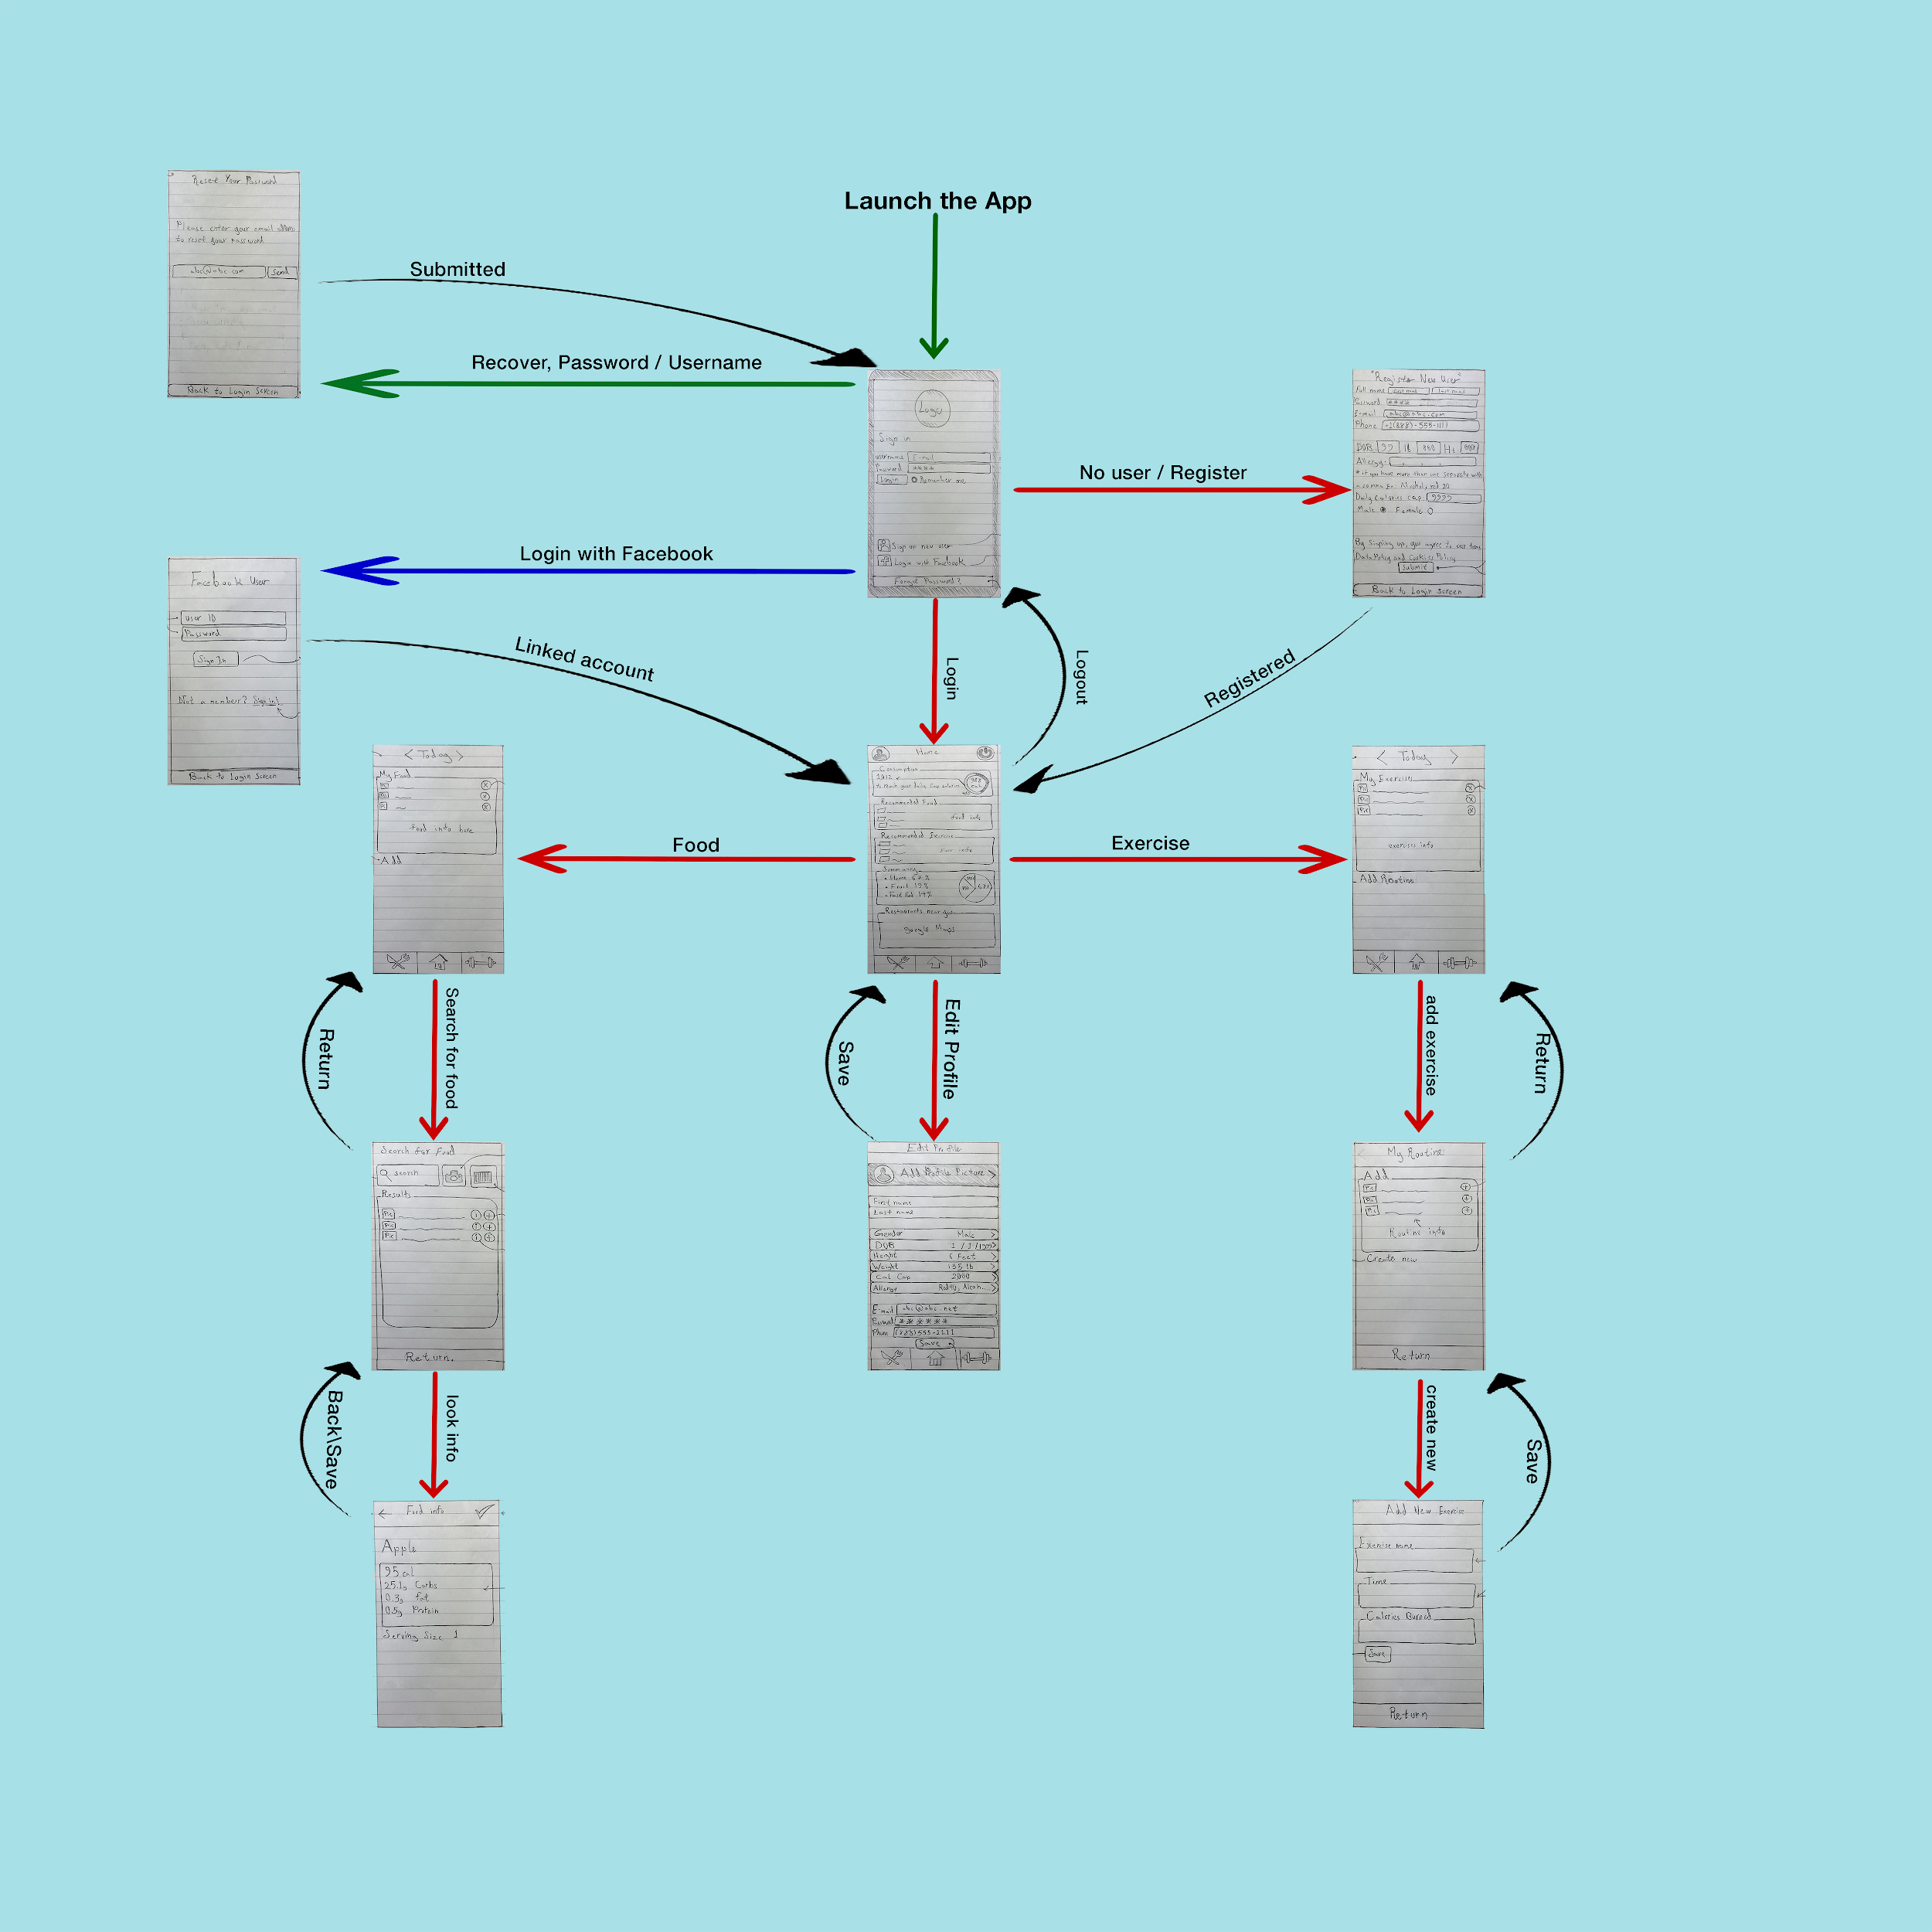

**State Diagram**

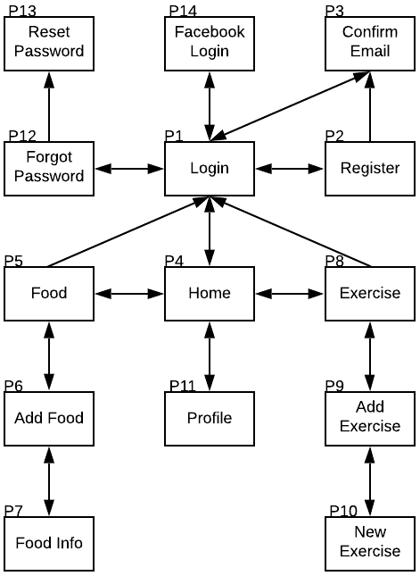

**Class Diagram**

There are no class diagrams at this point in time as we are uncertain about the technologies and are unable to reliably estimate a class diagram.

**User Stories & Use Case**

**[User]:** Both genders all ages.

**[Goal]:** login, register, recover password, search for food, , scan a food, take picture of custom food, look up for exercises, display graph.

**[Reason]:** Delete food, Delete exercise, Edit food, Edit exercise, Add food, Add exercise, Review recommendations, Review summary, Edit profile, tracking food calories, Avoiding allergens.

**#The equation:** As a [User], I want to [Goal], so I can [Reason]

*Down below some of possible user stories:*

* As a male, I want to register, so I can track food calories.
* As a female, I want to login, so I can see my chart graph.
* As an old male, I want to add food, so I can reach my cap calories.
* As a young female, I want to scan food, so I can avoid allergens.
* As a 14 years old girl , I want to recover my password, so I can track food calories.
* As an 88 years old man , I want to take pictures of food, so I can add custom food.

***Note:*** since the target contains all ages in both genders you can shuffle user, goal, and reason to generate more stories.

**Testing**

**Test Cases**

|  |  |  |
| --- | --- | --- |
| **Test Case ID** | **Scenario** | **Expected Results** |
| TR01 | Register email with valid email | Account should be made with the valid email |
| TR02 | Register email with 'not_an_email' | Message should appear warning of invalid email |
| TR03 | Register email with 'does_not_exist@mail.umkc.edu' | Message should appear warning of invalid email |
| TR04 | Register password with '87654321' | Account should be made with password '87654321' |
| TR05 | Register password with '1' | Message should appear warning of password being a minimum of 8 characters |
| TR06 | Register date of birth with 01/01/1995 | Account should be made with date of birth 01/01/1995 |
| TR07 | Register date of birth with 01/01/1800 | Message should appear warning of invalid date of birth |
| TR08 | Register date of birth with current date | Message should appear warning of invalid date of birth |
| TR09 | Register height with 67 | Account should be made with height 67 |
| TR10 | Register height with 125 | Message should appear warning of invalid height |
| TR11 | Register height with 5 | Message should appear warning of invalid height |
| TR12 | Register weight with 175 | Account should be created with weight 175 |
| TR13 | Register weight with 1500 | Message should appear warning of invalid weight |
| TR14 | Register weight with 10 | Message should appear warning of invalid weight |
| TR15 | Register allergies with '' | Account should be created without any allergies |
| TR16 | Register allergies with 'none' | Account should be created without any allergies |
| TR17 | Register allergies with 'None' | Account should be created without any allergies |
| TR18 | Register allergies with 'Null' | Account should be created without any allergies |
| TR19 | Register allergies with 'Clam' | Account should be created with allergy 'clam' |
| TR20 | Register allergies with 'Clam, Oyster' | Account should be created with allergies 'clam' and 'oyster' |
| TR21 | Register allergies with ' Clam ' | Account should be created with allergy 'clam' |
| TR22 | Register allergies with 'NA' | Account should be created without any allergies |
| TR23 | Register allergies with 'Not applicable' | Account should be created without any allergies |

**Test Case Document**

[**https://github.com/JAWolfe04/CS5551-Group-Project/blob/master/TestCases.ods**](https://github.com/JAWolfe04/CS5551-Group-Project/blob/master/TestCases.ods)

**Performance Tests**

|  |  |
| --- | --- |
| **Performance case ID** | **Scenario** |
| PR01 | Registration submission response time with 1 user is less than 1 second |

**Implementation**

* Angular 8
* Ionic
* MySQL
* NodeJS
* Express JS

**Existing Design/Services/REST API**

We are using Amplify and AWS Cognito to handle login services. We plan to use Nutritionix API for food querying and Clarifai for food recognition.

**Deployment**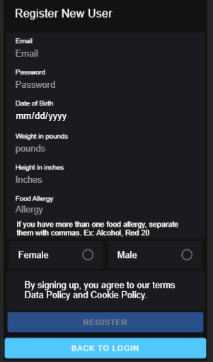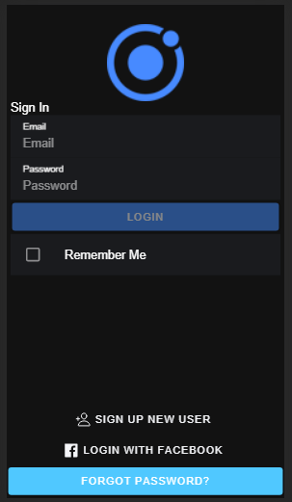

Login Page(Top)/Home Page(Bottom) Registration Page(Top)/Exercise Page(Bottom)

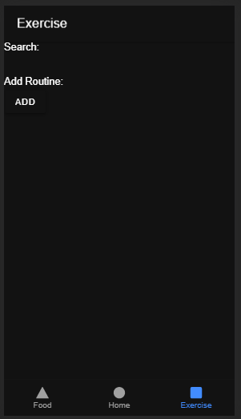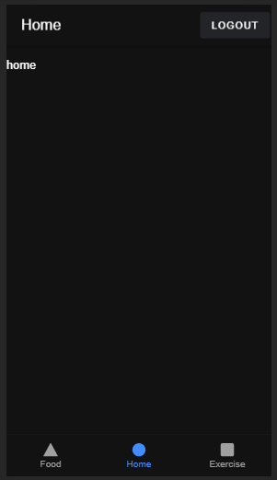

Routine Page Food Page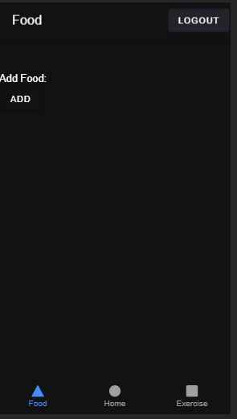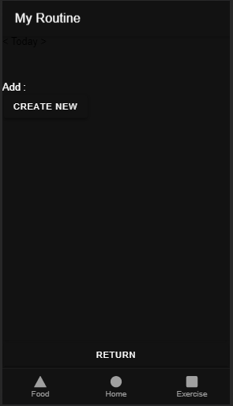

Add New Food Page Forgot Password Page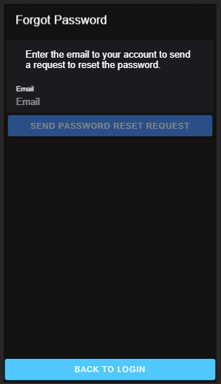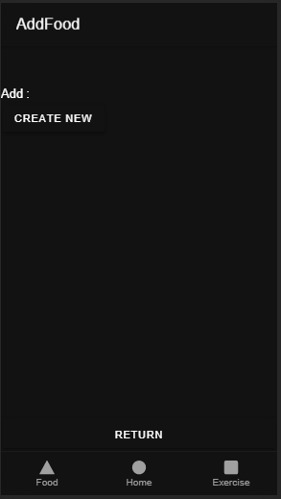

**Github**

<https://github.com/JAWolfe04/CS5551-Group-Project>

**Github Wiki**

<https://github.com/JAWolfe04/CS5551-Group-Project/wiki/Project-Increment-1>

**Project Management**

**Progress Board - Tasks**

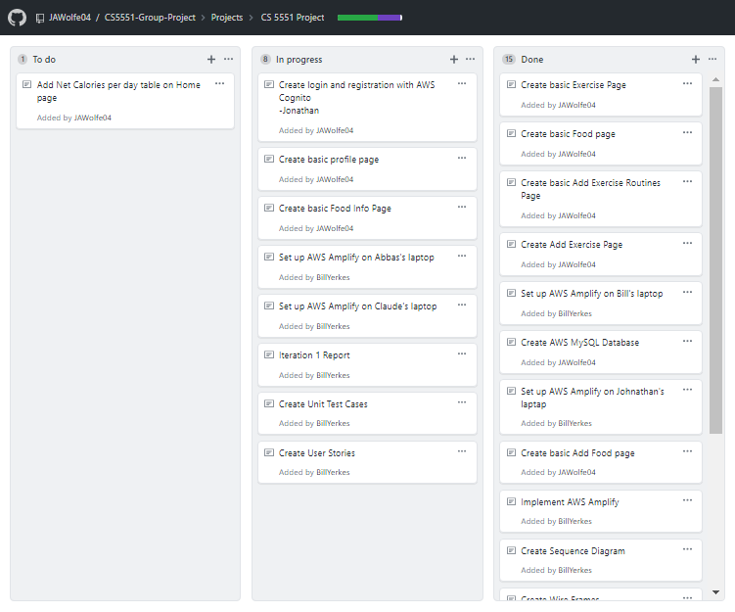

**Work completed (in hours)**

|  |  |  |  |  |  |
| --- | --- | --- | --- | --- | --- |
| **Task** | **Abbas** | **Bill** | **Claude** | **Jonathan** | **Total** |
| **Set Up Environment** | 1 | 1 | 1 | 2 | 5 |
| **Pick APIs** | 2 | 2 | 2 | 2 | 8 |
| **Design App** | 4 | 4 | 4 | 4 | 16 |
| **Design database/tables** | 1 |  | 2 |  | 3 |
| **Create User Stories** | 2 |  |  |  | 2 |
| **Create database/tables** |  |  | 4 |  | 4 |
| **Setup AWS Authentication** | 2 | 2 | 2 | 20 | 36 |
| **Setup AWS Database** |  | 1 |  |  | 1 |
| **Setup App Server** |  |  |  | 3 | 3 |
| **Create basic exercise page** | 1 |  |  |  | 1 |
| **Create basic food page** | 1 |  |  |  | 1 |
| **Create basic add exercise routines page** | 1 |  |  |  | 1 |
| **Create Add Exercise page** | 1 |  |  |  | 1 |
| **Create Add Food page** | 1 |  |  |  | 1 |
| **Create wireframes** | 4 |  |  |  | 4 |
| **Create site map** | 3 |  |  |  | 3 |
| **Create User Profile page** |  |  |  | 1 | 1 |
| **Create unit testing** |  | 3 |  | 1 | 4 |
| **Create Iteration 1 Report** | 3 | 3 | 3 | 6 | 15 |
| **Total** | 27 | 16 | 18 | 39 | 100 |

**Work to be completed**

|  |  |  |
| --- | --- | --- |
| **Task** | **Estimated Hours** | **Responsibility** |
| Add net calories per day on Home page | 3 | Abbas/Bill/Jonathan |
| Add ability to add consumed food | 2 | Abbas/Bill/Jonathan |
| Add ability to remove consumed food | 2 | Abbas/Bill/Jonathan |
| Add ability to add exercise | 2 | Abbas/Bill/Jonathan |
| Add ability to remove exercise | 2 | Abbas/Bill/Jonathan |

**Issues/Concerns**

Unable to complete the project as proposed in the project plan.

Amplify framework is difficult to use in a team setting.

Food recognition will be inaccurate in identifying foods.

AWS services and APIs may cost money to implement the project.

May not find all APIs to implement desired functionality.

**Bibliography**

No references used at this point in time